***Bilal KÜTÜK***

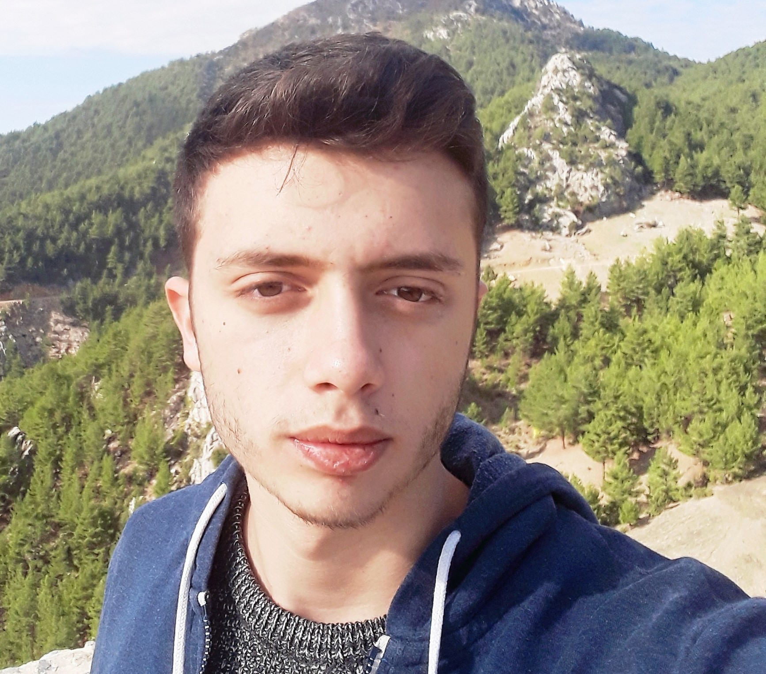

Ferahim Şalvuz Mahallesi 1663 Sokak No: 10 Tarsus/Mersin  
+90 535 639 10 51  
[bilalkutuk@gmail.com](mailto:bilalkutuk@gmail.com)

[www.linkedin.com/in/bilal-kütük-668510163](http://www.linkedin.com/in/bilal-kütük-668510163)

*I am 2nd year student of Electrical and Electronics Enginnering in Abdullah Gül University. Our education system in AGU is different from another universities. We make projects every term related with our lessons. The aim of these projects is to connect the real applications of electronics and the theories that we learn in the lectures. I wish to do my internship in your company and work in your company when I graduate.*

Education:

High School: Sesim Sarpkaya Fen Lisesi

Graduation: June 2017

University: Abdullah Gül University

Department: Electrical and Electronics Engineering (English)

Status: 2nd Year Student

GPA: 3.26

Relevant Skills:

|  |  |
| --- | --- |
| * Electrical engineering * Analytical skills * English | * Electronics engineering * Programming skills * Teamwork skills |

Project History:

1st Year Projects:

* **Electrical & Electronics Engineering 1st Year Integrated Project | Border Surveillance Systems**

Link: <https://tetrahedronx.blogspot.com/2018/12/department-of-electrical-electronics.html>

* **Electrical & Electronics 1st Year Capsule | Frequency Modulation Radio Receiver**

Link: <https://tetrahedronx.blogspot.com/2019/02/aircraft-band-receiver.html>

<https://drive.google.com/file/d/1JJZZJwIHqUghkMW-uIAPdWs_0F8PeHlP/view>

2nd Year Projects:

* **Real-time RGB LED Controlled Water Heater | Signal Acquisition & Processing by MATLAB, Arduino**
* **Electrocardiography (ECG) System and Signal Analysis Software Development Project**

Link: <https://docs.google.com/document/d/1So0qdgGMbYq3m3Div1WKC1-kg0XmQDhxE4dS7wXIF3U/edit>

* **Electrocardiography (ECG) System & Signal Analysis & Processing Project**

Link: <https://drive.google.com/file/d/1U5BW7PS8FqVfCZWKofFu8CufspmlY_Zc/view>